**LAPORAN PRAKTIKUM**

**PEMROGRAMAN 1**

Nama : Adam Nugroho

Npm : 4513210002

Contoh 01

* @ folder DialogBox

1. kotakDialog.java

import javax.swing.JOptionPane;

public class kotakDialog{

public static void main(String args[]){

JOptionPane.showMessageDialog(null,"WELCOME");

}

}

2. kotakDialog2.java

import javax.swing.JOptionPane;

public class kotakDialog2 {

public static void main(String args[]){

String nama = JOptionPane.showInputDialog("Siapa nama anda?");

String pesan = String.format("Welcome,%s!!",nama);

JOptionPane.showMessageDialog(null,pesan);

}

}

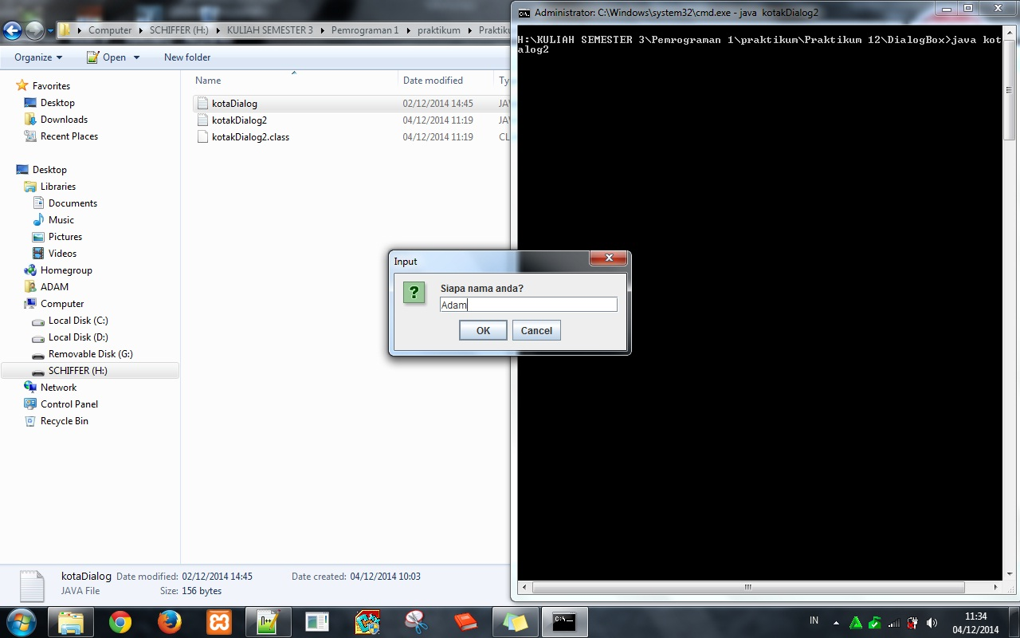

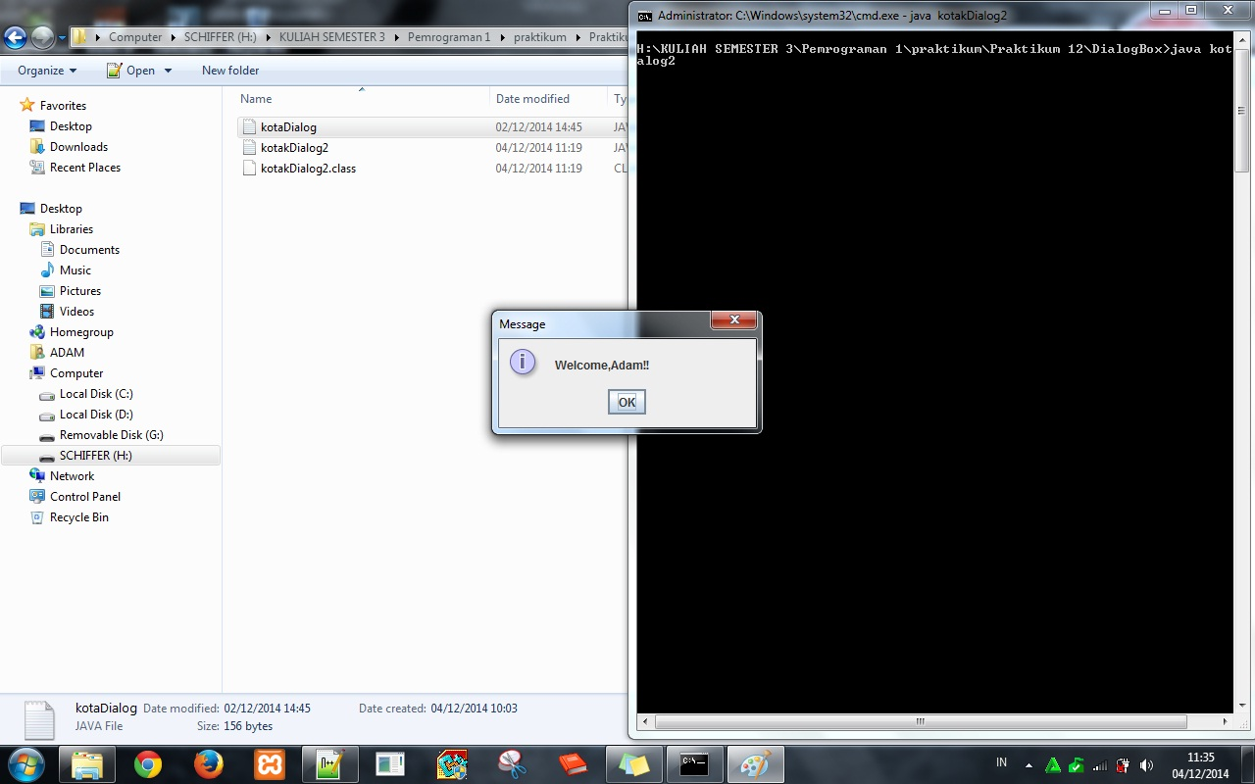

* @ folder Inhertance bangun

1. bangun.java

class bangun{

double phi, r, p, l, a, t, s1, s2, s3, rusuk;

public bangun(){

phi=3.14;

r=10;

p=20;

l=5;

a=s1=12;

s2=s3=10;

t=8;

rusuk=4;

}

}

2. bola.java

class bola extends bangun{

double hitungLuasBola(){

double luas;

luas=4*phi*r*r;

return luas;

}

double hitungVolumeBola(){

double volume;

volume=(4*phi*r*t*t*t)/3;

return volume;

}

}

3. kubus.java

|  |
| --- |
| class kubus extends bangun{  double hitungLuasKubus(){  double luas;  luas=6*rusuk*rusuk;  return luas;  }  double hitungKelilingKubus(){  double keliling;  keliling=12*rusuk;  return keliling;  }  double hitungVolumeKubus(){  double volume;  volume=rusuk*rusuk*rusuk;  return volume;  }  } |

4. lingakaran.java

|  |
| --- |
| class lingkaran extends bangun{  double hitungLuasLing(){  double luas;  luas=phi*r*r;  return luas;  }  double hitungKelilingLing(){  double keliling;  keliling=2*r*r;  return keliling;  }  } |

5. segiEmpat.java

|  |
| --- |
| class segiEmpat extends bangun{  double hitungLuasSegi4(){  double luas;  luas=p*l;  return luas;  }  double hitungKelilingSegi4(){  double keliling;  keliling=2*(p+l);  return keliling;  }  } |

6. segiTiga.java

|  |
| --- |
| class segiTiga extends bangun{  double hitungLuasSegi3(){  double luas;  luas=0.5*a*t;  return luas;  }  double hitungKelilingSegi3(){  double keliling;  keliling=s1+s2+s3;  return keliling;  }  } |

7. tabung.java

|  |
| --- |
| class tabung extends bangun{  double hitungLuasAlasTabung(){  double luasAlas;  luasAlas=phi*r*r;  return luasAlas;  }  double hitungLuasSelimutTabung(){  double luasselimut;  luasselimut=2*phi*r*t;  return luasselimut;  }  double hitungVolumeTabung(){  double volume;  volume=phi*r*r*t;  return volume;  }  } |

8. TugasInheritance

|  |
| --- |
| public class TugasInheritance{  public static void main(String[]args){  lingkaran ling1, ling2;  segiEmpat segi4a, segi4b;  segiTiga segi3a, segi3b;  bola bola1, bola2;  kubus kub1, kub2, kub3;  tabung tab1, tab2, tab3;    ling1=new lingkaran();  ling2=new lingkaran();  segi4a=new segiEmpat();  segi4b=new segiEmpat();  segi3a=new segiTiga();  segi3b=new segiTiga();  bola1=new bola();  bola2=new bola();  kub1=new kubus();  kub2=new kubus();  kub3=new kubus();  tab1=new tabung();  tab2=new tabung();  tab3=new tabung();  System.out.println("===TUGAS INHERITANCE - Pemrograman 1===");  System.out.println("Nama : Adam Nugroho");  System.out.println("NPM : 4513210002");  System.out.println("========================================");  System.out.println(" ");  System.out.println("LINGKARAN");  System.out.println("Luas Lingkaran = "+ling1.hitungLuasLing());  System.out.println("Keliling Lingkaran = "+ling2.hitungKelilingLing());  System.out.println(" ");  System.out.println("SEGIEMPAT");  System.out.println("Luas Segi Empat = "+segi4a.hitungLuasSegi4());  System.out.println("Keliling Segi Empat = "+segi4b.hitungKelilingSegi4());  System.out.println(" ");  System.out.println("SEGITIGA");  System.out.println("Luas Segi Tiga = "+segi3a.hitungLuasSegi3());  System.out.println("Keliling Segi Tiga = "+segi3b.hitungKelilingSegi3());  System.out.println(" ");  System.out.println("BOLA");  System.out.println("Luas Permukaan Bola = "+bola1.hitungLuasBola());  System.out.println("Keliling Volume Bola = "+bola2.hitungVolumeBola());  System.out.println(" ");  System.out.println("KUBUS");  System.out.println("Luas Permukaan Kubus = "+kub1.hitungLuasKubus());  System.out.println("Luas Keliling Kubus = "+kub2.hitungKelilingKubus());  System.out.println("Keliling Volume Kubus = "+kub3.hitungVolumeKubus());  System.out.println("TABUNG");  System.out.println("Luas Luas Alas Tabung = "+tab1.hitungLuasAlasTabung());  System.out.println("Luas Luas Selimut Tabung = "+tab2.hitungLuasSelimutTabung());  System.out.println("Keliling Volume Tabung = "+tab3.hitungVolumeTabung());  }  } |

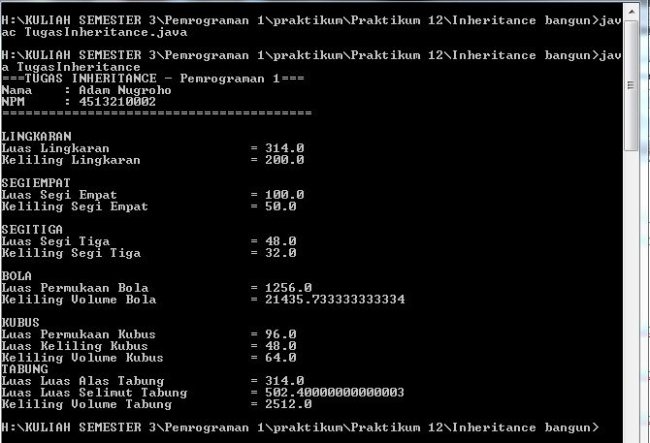

* @ folder Overloading Overriding

1. belajar.java

class Belajar{

double a,b;

public Belajar(){

a=10;

b=5;

}

String matkul(){

String namaMatkul;

namaMatkul = "Pemrograman Internet";

return namaMatkul;

}

double tambah(){

double total;

total=a+b;

return total;

}

double tambah(double c, double d){

double total;

total=c+d;

return total;

}

}

2. pelajaran.java

class pelajaran extends Belajar{

String Matkul(){

String namaMatkul;

namaMatkul="Pemrograman Internet 1";

return namaMatkul;

}

}

3. terusBelajar.java

public class terusBelajar{

public static void main(String[]args){

Belajar m,t;

pelajaran p;

m=new Belajar();

t=new Belajar();

p=new pelajaran();

System.out.println("Hasil penambahan 'method' = " +t.tambah());

System.out.println("Hasil penambahan 'method overloading' = "+t.tambah(20,8));

System.out.println("Nama Matkul 'method' = "+m.matkul());

System.out.println("Nama Matkul 'method overriding' = "+p.matkul());

}

}

